UBUNTU COMMANDS 3

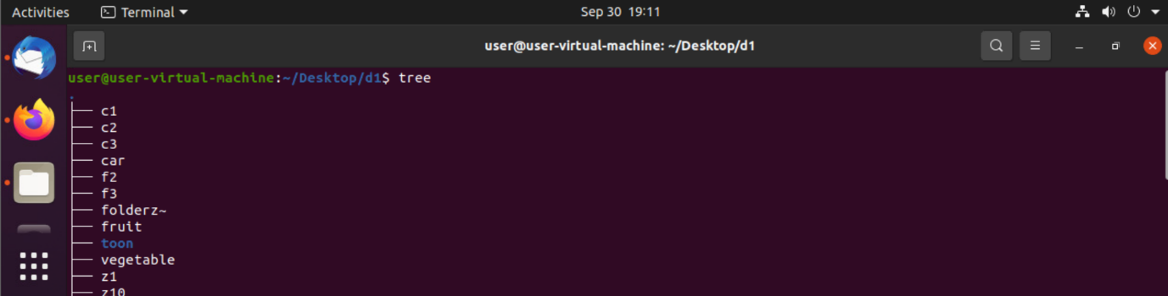

tree- It gives the hierarchical structure of a particular folder.

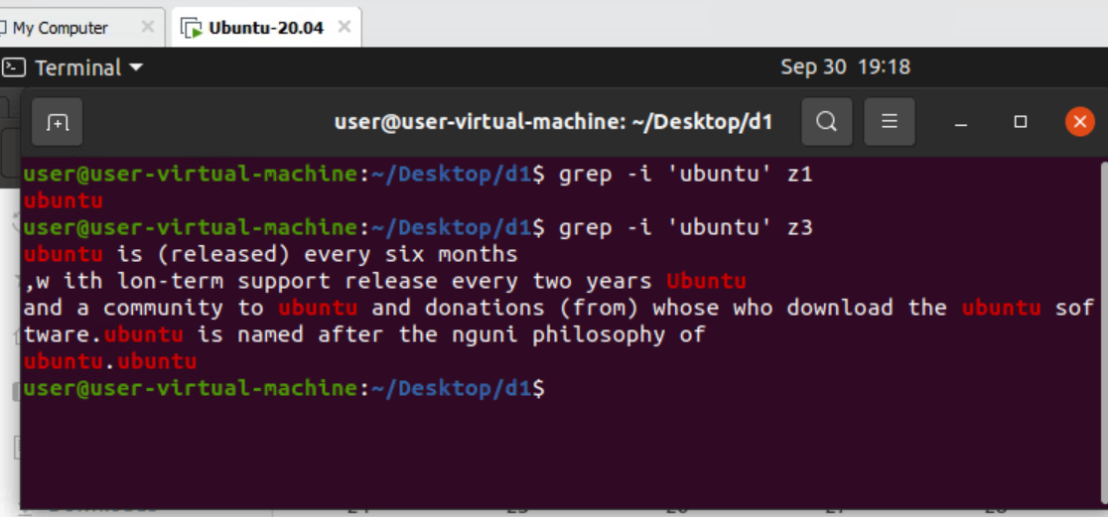

grep -i ‘ubuntu’ z3

grep -i is used to print all ‘ubuntu’ present in z3(filename)

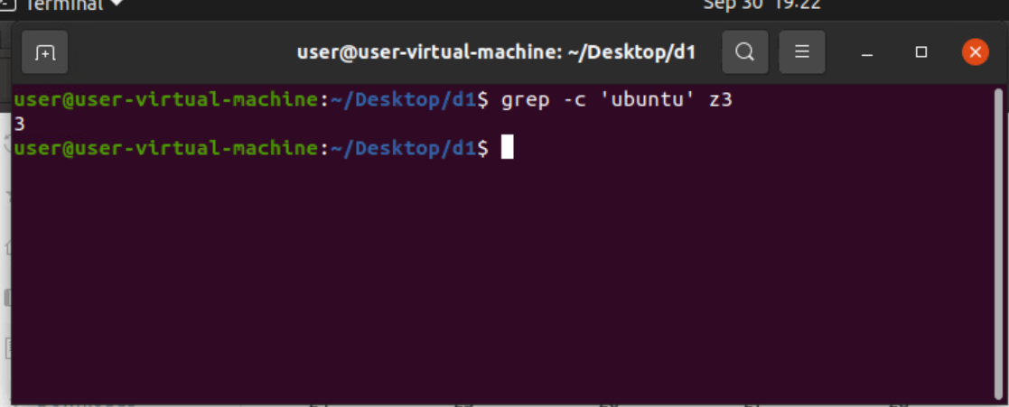

grep -c- gives the repetition of ‘ubuntu’.

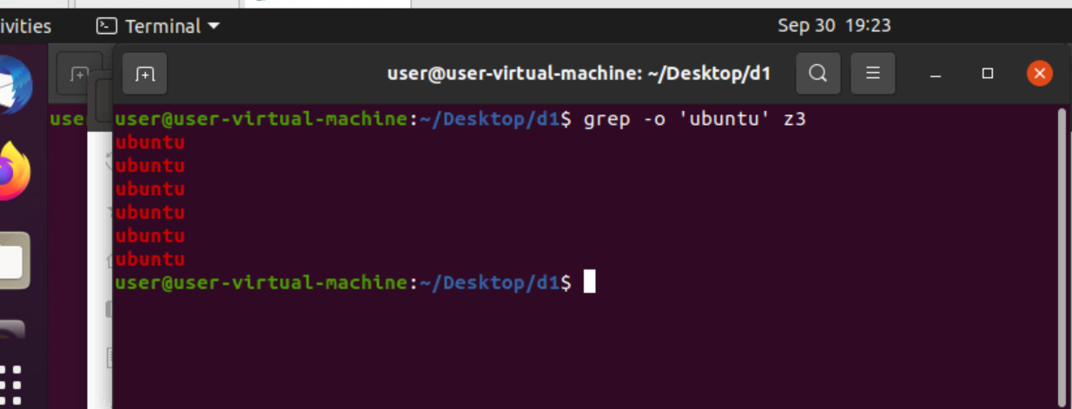

grep -o – prints all ubuntu present in the file.

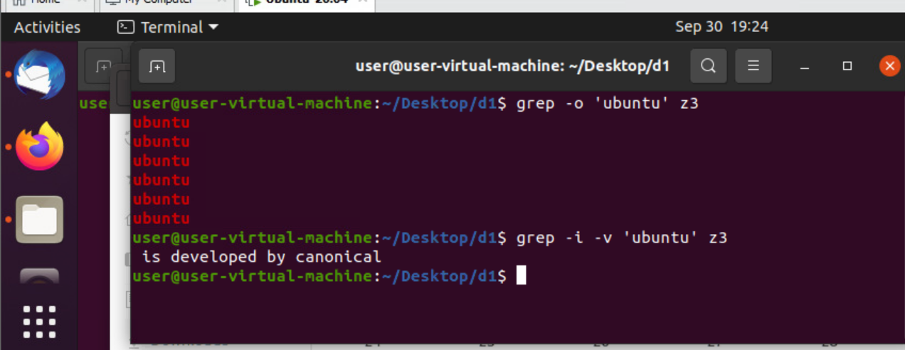

grep -i -v- deletes ‘ubuntu’ and prints the rest.

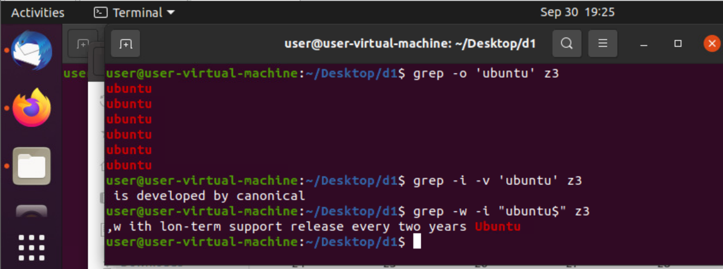

grep -w -i- “ubuntu$”- prints ‘ubuntu’which present at the end.

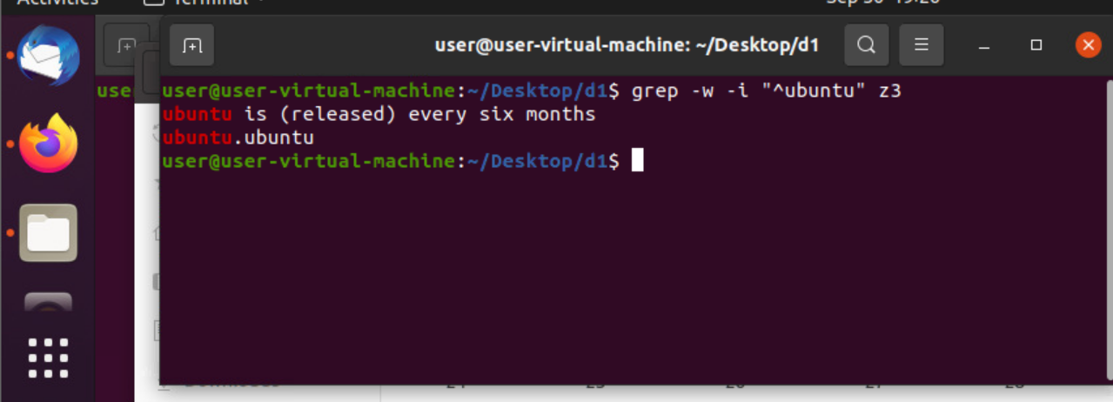

grep -w -i- “^ubuntu”-prints all ‘ubuntu’ present at the beginning.

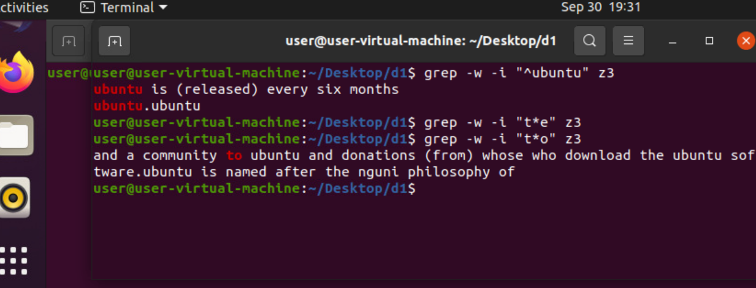

grep -w -i “t\*o”- search for the word & prints

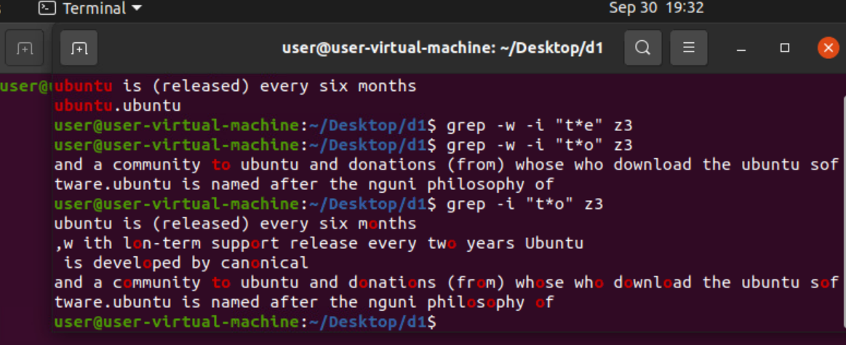

grep -i “t\*o”-searches for the word ‘o’ and highlights it.

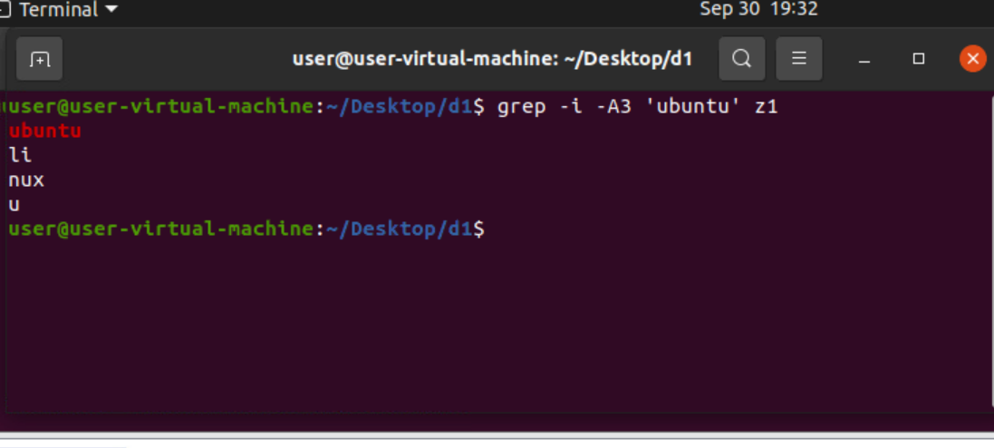

grep -i -A3- prints three lines after the ‘ubuntu’.

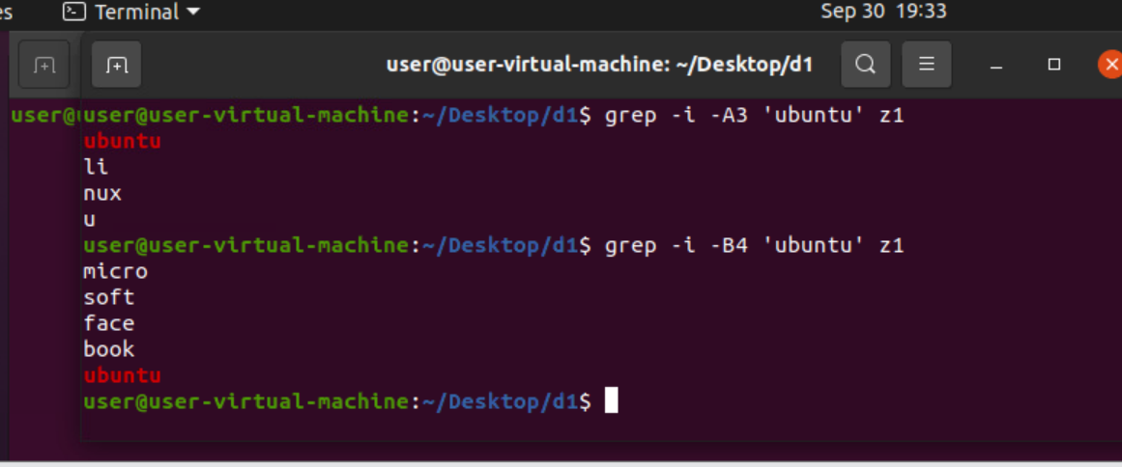

grep -i -B4- prints four lines before ubuntu.

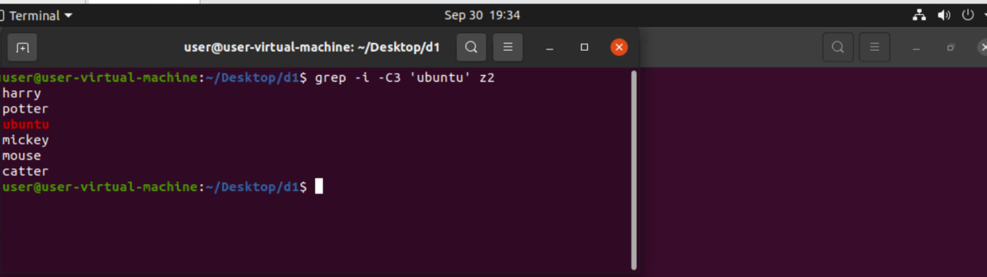

grep -i -C3- prints three lines before & after of ’ubuntu’.

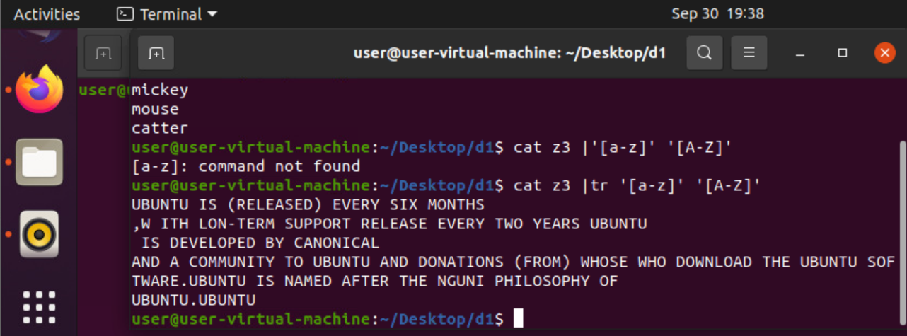

Cat z3- prints the content of the file.

tr ‘[a-z]’ ‘[A-Z]’- translates lower case to upper case.

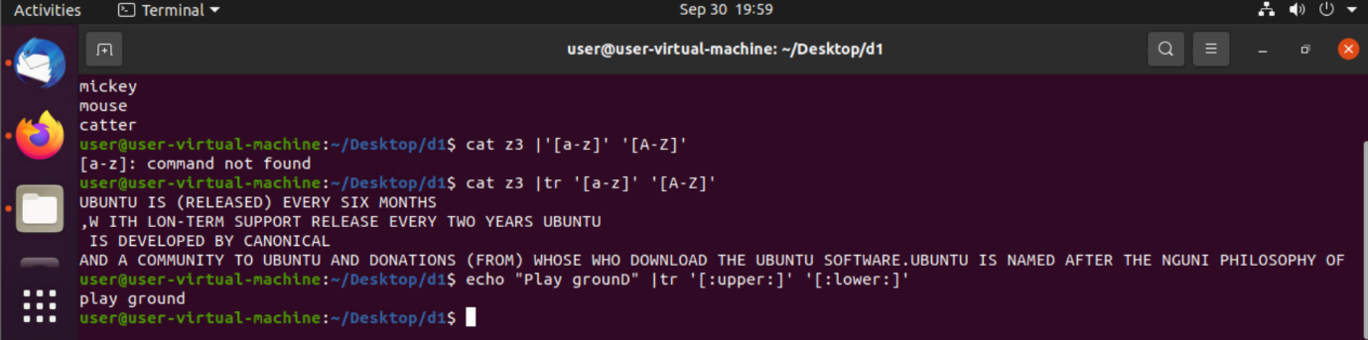

echo ”Play grounD” – prints the text within the quotes.

tr – ‘[:upper:]’ ‘[:lower:]’- translates upper case to lower case.

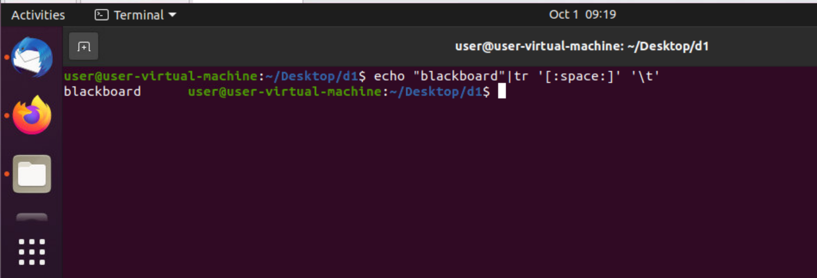

tr ‘[:space:]’ ‘\t’- gives space after blackboard.

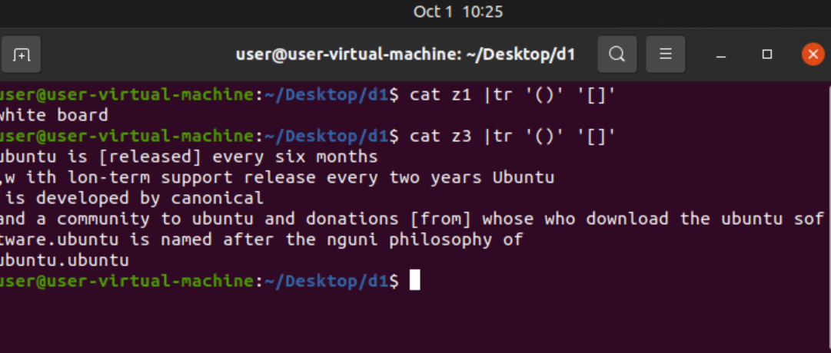

tr ’()’ ‘[]’- ()braces will become [] using this command.

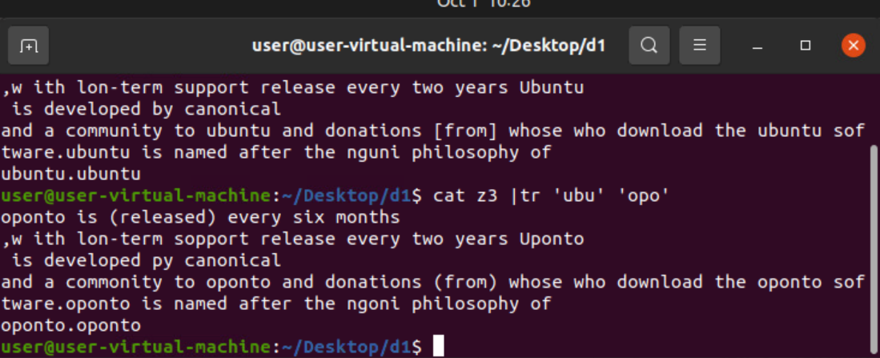

tr ‘ubo’ ‘opo’- translates ‘ubo’ into ‘opo’.

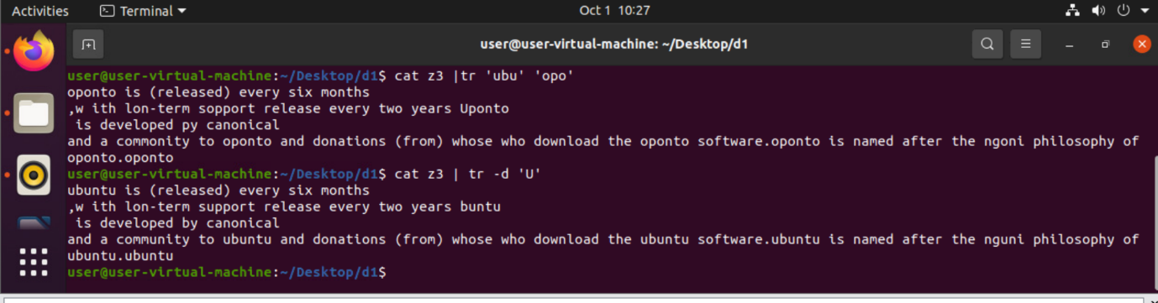

tr -d ‘U’- deletes ‘U’(only the upper case).

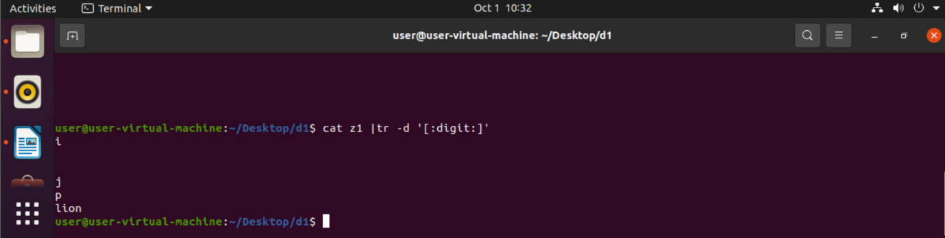

tr -d ‘[:digits:]’ – removes the digits.

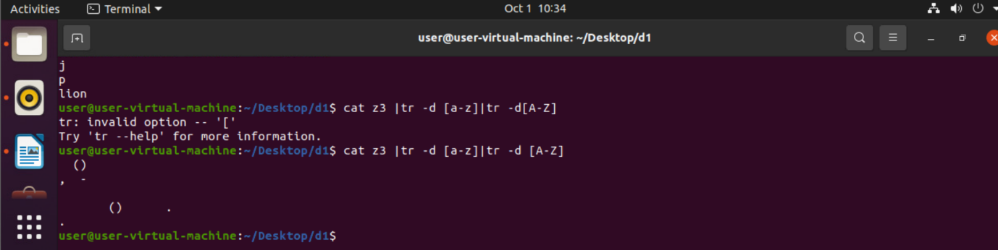

tr -d [a-z]|tr -d [A-Z] -removes all characters.

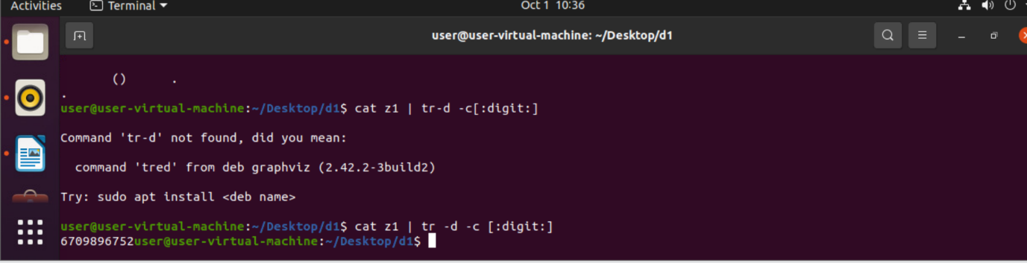

tr -d-c[:digit:]-prints constants by neglecting characters.

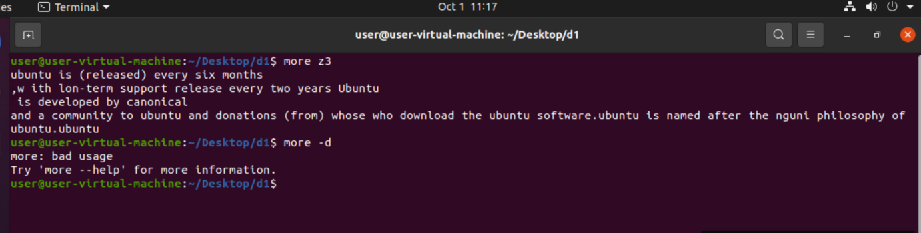

more- prints all the contents of the file. This keyword is used to print large files.

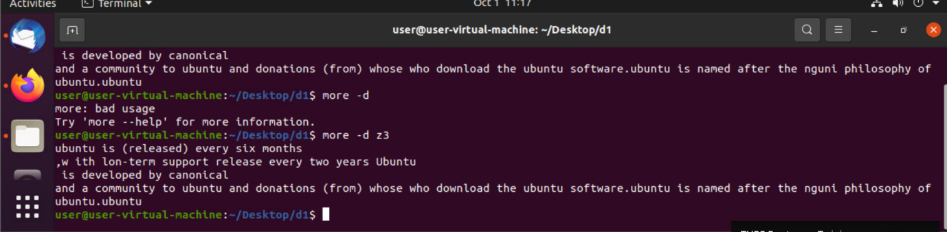

more -d- describes more about the file.

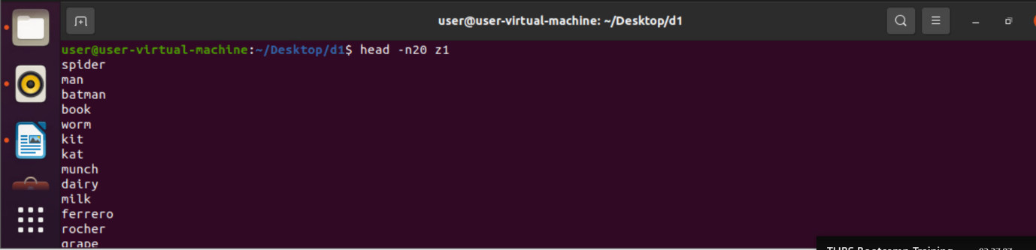

Head -n20- list downs first 20 lines of the file

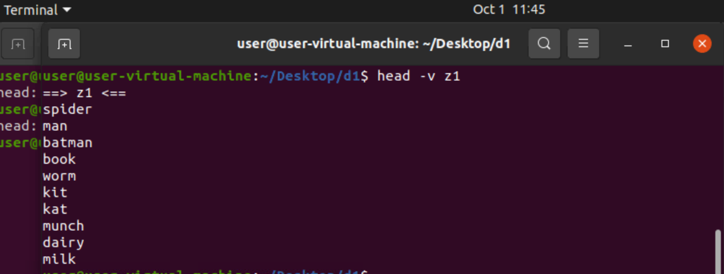

head -v- prints default 10 lines of the text with the file name.

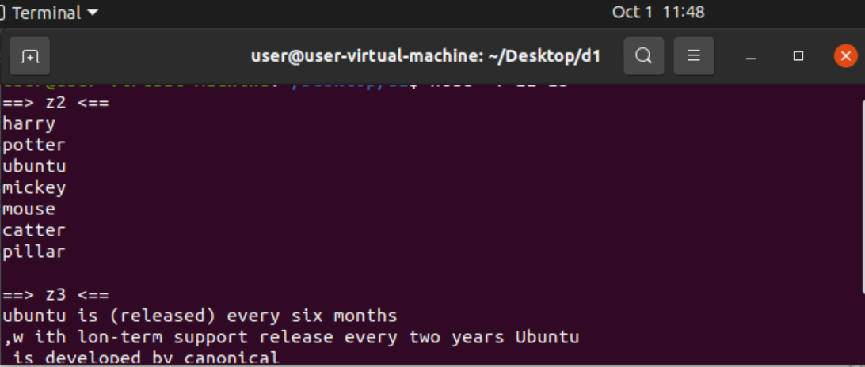

prints two files with filename.

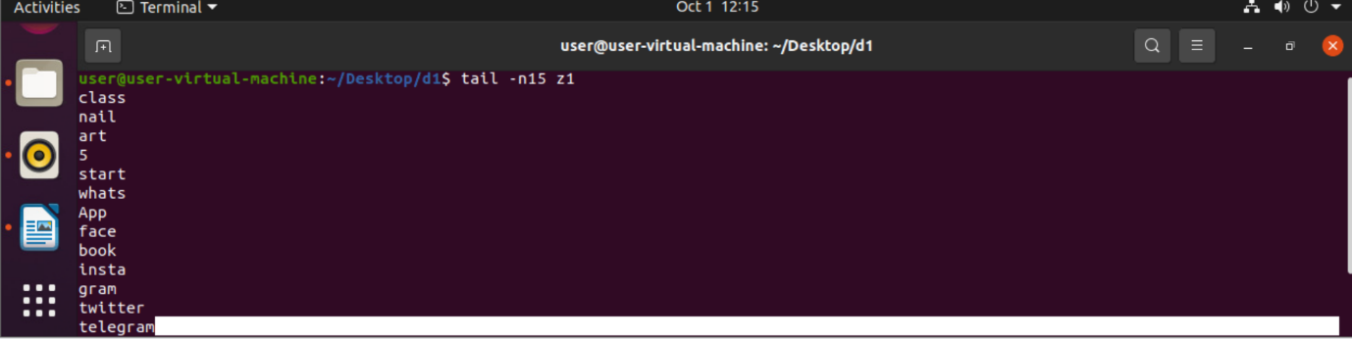

tail -n15- prints last 15 lines of the file.

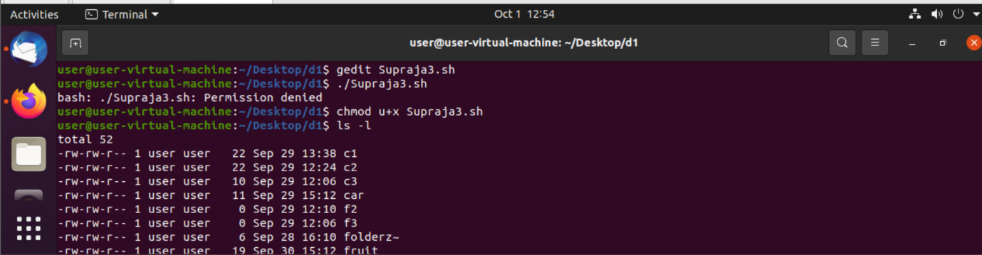

gedit- used to create a file

Supraja.sh- is a shell name with extension sh

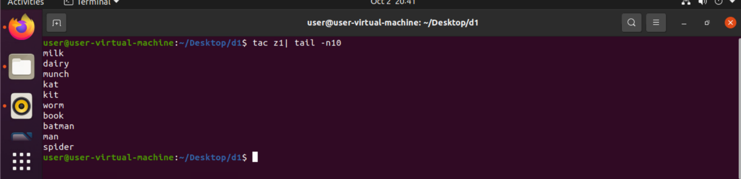

Tac -reverses the contents of z1.